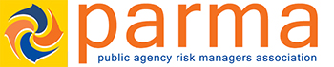

BAY AREA CHAPTER MEETING AND NETWORKING BREAKFAST
DECEMBER 7, 2016

LOCATION: Beeb’s Clubhouse at Las Positas Golf Course
915 Clubhouse Drive, Livermore, CA 94551

(From Eastbound I-580 take the Airway Blvd Exit and proceed right on
Clubhouse Drive)

RESERVATIONS: Please confirm your attendance by contacting Janet Hamilton at jlhamilton@cityoflivermore.net

COST: **FREE FOR ALL PUBLIC AGENCY EMPLOYEES **
$25 for All Others. Registration includes networking hot breakfast.

Those attending may pay in advance or at the door. Make your checks payable to PARMA. Checks can be mailed to:

Heather Davidson

North Bay Schools Insurance Authority

380A Chadbourne Road, Fairfield, CA 94534

Credit Card # ________________________________________________________
Exp. Date _________ Billing Zip Code ___________ CCV# ________
Signature:
Please note paying by credit card includes transaction fee (3.5% + $0.15 for manual or 2.75% for swiped transactions)

SPONSORS:

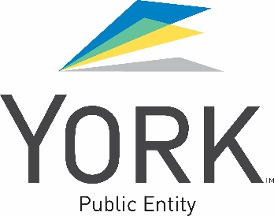
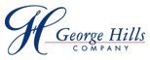

AGENDA

8:30 – 9:05 Registration/Networking Hot Breakfast

9:05 – 9:15 Introduction/Brief Announcements

9:15-11:00 POLICE CIVIL LIABILTY UNDER STATE AND FEDERAL (Section 1983) LAW

Matthew J. Orebic, Law Office of Matthew J. Orebic

11:00 – 11:15 Break

11:15 – 12:00 Education Code and Workers’ Compensation Benefits
Hanna Brophy Law Firm

12:00 – 12:30 Announcements/Sponsor Recognition/Wrap-Up/Light Appetizers for the Road

Future Meeting Topics and Suggestions:
If you or someone you know would like to be a presenter at a future meeting, please contact Steve Schwarz at sschwarz@fremont.gov.

DRAWINGS WILL BE HELD FOR DOOR PRIZES!

VENDORS ARE WELCOME AND ENCOURAGED TO BRING PRIZES FOR THE DRAWING! PLEASE MAKE SURE TO ATTACH YOUR BUSINESS CARD.

After the meeting, we will hold a drawing for public agency members for free registration to the Annual PARMA Conference. For every meeting you attended this year, you will have an opportunity to win! We will send out an email blast to announce the winner!
PARMA ANNUAL CONFERENCE
The 2017 PARMA conference will take place at the Disneyland Hotel in Anaheim February 12-15, 2016. Registration is now open on the PARMA website at
http://www.parma.com. Also, see website for scholarship information.
Hope to see you there!

