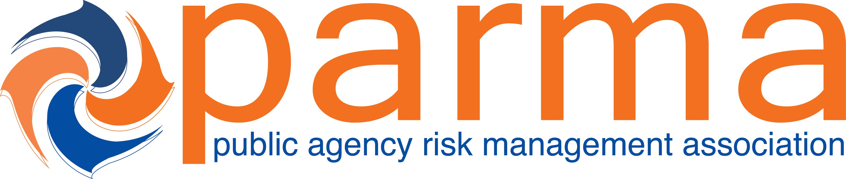

Session Title: What’s Work Got to Do with It? Emerging Law and Litigation Over Vocational Apportionment
CEs Earned: 1.25 Hours

Presented To: Date: 3/2/22

Certificate of Attendance from Public Agency Risk Management Association’s Annual Conference

Paul Zeglovitch
Paul Zeglovitch
PARMA Education Committee Chair
The recipient earned Continuing Education Credits in accordance with the guidelines established by the National Task Force on Continuing Education for completion of the program.

