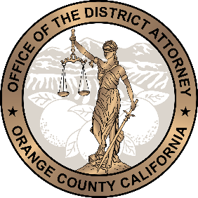
OFFICE OF THE
DISTRICT ATTORNEY
ORANGE COUNTY, CALIFORNIA
TODD SPITZER

WORKER’S COMPENSATION INSURANCE FRAUD UNIT
CONTACT INFORMATION

E-mail for submission of e-FD1’s & attachments: wcfraudfd1@da.ocgov.com

Assistant Deputy District Attorney Investigative Supervisor
Tammy Spurgeon Loren Dawson
Tammy.Spurgeon@da.ocgov.com Loren.Dawson@da.ocgov.com

Applicant Fraud Cases

DDA Pamela J. Leitao Inv. Timothy Lancaster
Pamela.Leitao@da.ocgov.com Timothy.Lancaster@da.ocgov.com
(714) 648-3683 (office) (714) 664-3905
(714) 403-4286 (work cell)

Provider Fraud Cases

Asst. Head of Court
Sr. DDA Shaddi Kamiabipour
Shaddi.Kamibipour@da.ocgov.com
(714) 664-3948 (office)
(714) 403-0761 (work cell)

Provider Fraud Cases (Involving attorneys)

DDA Noor Hasan
Noorul.Hasan@da.ocgov.com
(714) 664-3683 (office)
(714) 402-6127 (work cell)

Premium Fraud Cases

DDA Tasha Soroosh
Tasha.Soroosh@da.ocgov.com
(714) 648-3672
(714) 349-6249

Public Works Fraud

DDA Ray Diaz
Raymund.Diaz@da.ocgov.com
(714) 648-3682 (office)
(714) 402-0251

Auto Insurance Fraud

Stephen Tanizaki
Stephen.Tanizaki@da.ocgov.com
(714) 648-3686

