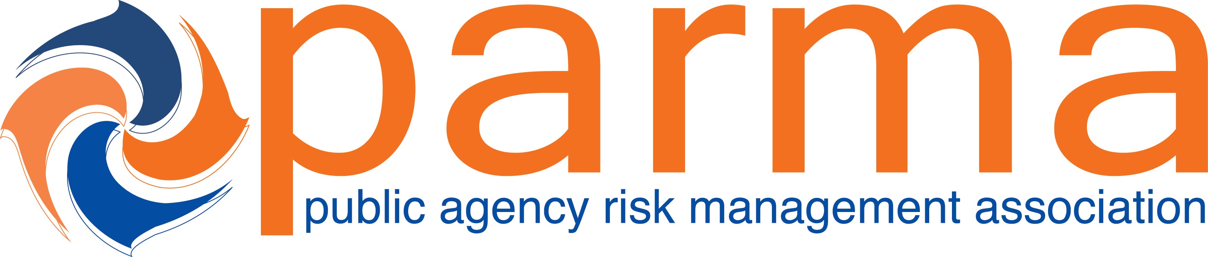

Session Title: G4 - Does Your Indemnity Pass the Attorney Test?

CE Credits Earned: 1.25

Presented To:____________________________________________________________Date:_______________________

Certificate of Attendance from the 2021 Public Agency Risk Management Association Conference

_________________________________________
Catherine Jones, PARMA President

The recipient earned Continuing Education Credits in accordance with the guidelines established by the National Task Force on Continuing Education for completion of the program.

