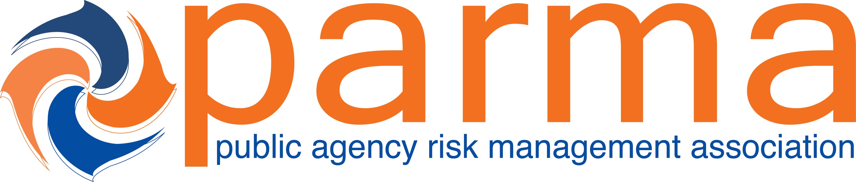

Session Title: Risky Business – A Primer on Minimizing Risk in Dangerous Conditions and Inverse Condemnation Cases
CEs Earned: 1.5 Hours

Presented To: Date: 3/1/22

Certificate of Attendance from Public Agency Risk Management Association’s Annual Conference

Paul Zeglovitch
Paul Zeglovitch
PARMA Education Committee Chair
The recipient earned Continuing Education Credits in accordance with the guidelines established by the National Task Force on Continuing Education for completion of the program.

